1. Single Inheritance
Problem Statement:
Write a Java program to demonstrate single inheritance by creating a Person superclass containing the name and age of a person. Create a Student subclass containing roll number and branch. Inherit the properties of Person and display the complete student details.
class Person {
String name;
int age;
public Person(String name, int age) {
this.name = name;
this.age = age;
}
public void displayPersonDetails() {
System.out.println("Name: " + name);
System.out.println("Age: " + age);
}
}
class Student extends Person {
int rollNumber;
String branch;
public Student(String name, int age, int rollNumber, String branch) {
super(name, age);
this.rollNumber = rollNumber;
this.branch = branch;
}
public void displayStudentDetails() {
displayPersonDetails();
System.out.println("Roll Number: " + rollNumber);
System.out.println("Branch: " + branch);
}
}
public class SingleInheritanceDemo {
public static void main(String[] args) {
Student student1 = new Student("Vaibhav", 20, 101, "Computer Science");
System.out.println("=== Student Profile ===");
student1.displayStudentDetails();
}
}
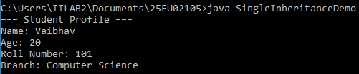

2. Using super Keyword
Problem Statement:
Write a Java program to demonstrate the use of the super keyword. Create a Vehicle superclass with a speed variable and a display() method. Create a Car subclass with a model variable and override the display() method. Use super to access the superclass variable and method.
class Vehicle{
int speed=104;
void display(){
System.out.println("Speed of the vehicle is "+speed+"km/h");
}
}
class Car extends Vehicle{
int speed=197;
String model="Sports Car";
@Override
void display(){
System.out.println("Car Model: "+model);
System.out.println("Car Speed :"+speed+"km/h");
System.out.println("Vehicle Speed: "+super.speed+"km/h");
}
}
public class SuperKeywordDemo{
public static void main(String[] args){
Car car=new Car();
car.display();
}
}

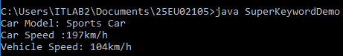

3. Multilevel Inheritance
Problem Statement:
Write a Java program to demonstrate multilevel inheritance by creating three classes: Person, Employee, and Manager. The Person class should contain personal details, Employee should contain employee details, and Manager should contain department details. Display all the details using inherited properties.
class Person {
String name;
int age;
public Person(String name, int age) {
this.name = name;
this.age = age;
}
void displayPersonDetails() {
System.out.println("Name: " + name);
System.out.println("Age: " + age);
}
}
class Employee extends Person {
int empId;
double salary;
public Employee(String name, int age, int empId, double salary) {
super(name, age); // Call Person constructor
this.empId = empId;
this.salary = salary;
}
public void displayEmployeeDetails() {
displayPersonDetails();
System.out.println("Employee ID: " + empId);
System.out.println("Salary: " + salary);
}
}
class Manager extends Employee {
String dep;
public Manager(String name, int age, int empId, double salary, String dep) {
super(name, age, empId, salary); // Call Employee constructor
this.dep = dep;
}
public void displayManagerDetails() {
displayEmployeeDetails();
System.out.println("Department: " + dep);
}
}
public class MultilevelInheritanceDemo {
public static void main(String[] args) {
Manager manager = new Manager("Siddhu", 42, 5001, 85000.0, "Operations");
System.out.println("=== Profile ===");
manager.displayManagerDetails();
}
}
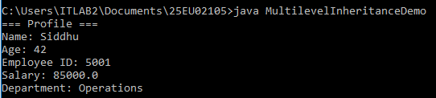

4. Method Overriding
Problem Statement:
Write a Java program to demonstrate method overriding by creating an Animal superclass with a sound() method. Create subclasses Dog and Cat that override the sound() method with their respective sounds. Display the appropriate sound for each animal.
class Animal {
void sound() {
System.out.println("Animal makes a sound");
}
}

class Dog extends Animal {
@Override
void sound() {
System.out.println("Dog barks: Woof Woof");
}
}

class Cat extends Animal {
@Override
void sound() {
System.out.println("Cat meows: Meow Meow");
}
}

public class MethodOverridingDemo {
public static void main(String[] args) {
Animal myAnimal = new Animal();
Animal myDog = new Dog();
Animal myCat = new Cat();

myAnimal.sound();
myDog.sound();
myCat.sound();
}
}
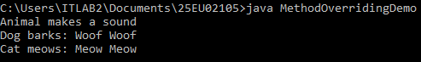

5. Dynamic Method Dispatch
Problem Statement:
Write a Java program to demonstrate dynamic method dispatch using a superclass Shape and subclasses Circle, Rectangle, and Triangle. Override the draw() method in each subclass and use a superclass reference to invoke the appropriate overridden method at runtime.
class Shape {
void draw() {
System.out.println("Drawing a generic shape");
}
}

class Circle extends Shape {
@Override
void draw() {
System.out.println("Drawing a Circle");
}
}

class Rectangle extends Shape {
@Override
void draw() {
System.out.println("Drawing a Rectangle");
}
}

class Triangle extends Shape {
@Override
void draw() {
System.out.println("Drawing a Triangle");
}
}

public class DynamicDispatchDemo {
public static void main(String[] args) {
// Superclass reference variable
Shape ref;

// Assign Circle object
ref = new Circle();
ref.draw();

// Assign Rectangle object
ref = new Rectangle();
ref.draw();

// Assign Triangle object
ref = new Triangle();
ref.draw();
}
}
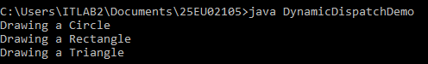

6. super with Method Overriding
Problem Statement:
Write a Java program to demonstrate the use of super with method overriding. Create an Employee class with a display() method and derive a Manager class that overrides the method. Use super.display() in the subclass to invoke the superclass implementation before displaying the manager details.
class Employee {
String name = "Anand";
double salary = 75000.0;

void display() {
System.out.println("Name: " + name);
System.out.println("Salary: $" + salary);
}
}

class Manager extends Employee {
String department = "Engineering";

@Override
void display() {
// Invoke superclass implementation first
super.display();

// Display additional subclass details
System.out.println("Department: " + department);
}
}

public class SuperOverrideDemo {
public static void main(String[] args) {
Manager manager = new Manager();
System.out.println("=== Manager Details ===");
manager.display();
}
}
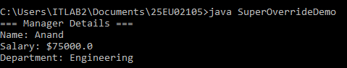

7. Multilevel Inheritance for Salary Calculation
Problem Statement:
Write a Java program to create a multilevel inheritance hierarchy Employee → Developer → SeniorDeveloper. Store basic salary in the Employee class, programming allowance in the Developer class, and project allowance in the SeniorDeveloper class. Calculate and display the total salary.
class Employee {
String name;
double basicSalary;

Employee(String name, double basicSalary) {
this.name = name;
this.basicSalary = basicSalary;
}

double calculateTotalSalary() {
return basicSalary;
}

void displayDetails() {
System.out.println("Employee Name: " + name);
System.out.println("Basic Salary: " + basicSalary);
}
}

class Developer extends Employee {
double programmingAllowance;

Developer(String name, double basicSalary, double programmingAllowance) {
super(name, basicSalary);
this.programmingAllowance = programmingAllowance;
}

@Override
double calculateTotalSalary() {
return super.calculateTotalSalary() + programmingAllowance;
}

@Override
void displayDetails() {
super.displayDetails();
System.out.println("Programming Allowance: " + programmingAllowance);
}
}

class SeniorDeveloper extends Developer {
double projectAllowance;

SeniorDeveloper(String name, double basicSalary, double programmingAllowance, double projectAllowance) {
super(name, basicSalary, programmingAllowance);
this.projectAllowance = projectAllowance;
}

@Override
double calculateTotalSalary() {
return super.calculateTotalSalary() + projectAllowance;
}

@Override
void displayDetails() {
super.displayDetails();
System.out.println("Project Allowance: " + projectAllowance);
System.out.println("Total Salary: " + calculateTotalSalary());
}
}

public class SalaryCalculator {
public static void main(String[] args) {
SeniorDeveloper seniorDev = new SeniorDeveloper("Alex Smith", 60000.00, 15000.00, 10000.00);

System.out.println("--- Senior Developer Details ---");
seniorDev.displayDetails();
}
}
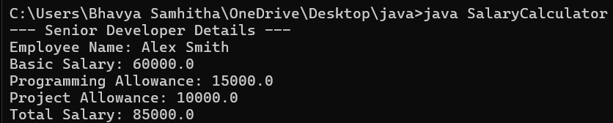

8. Dynamic Method Dispatch for Bank Accounts
Problem Statement:
Write a Java program to demonstrate dynamic method dispatch using a superclass BankAccount with a calculateInterest() method. Create SavingsAccount and CurrentAccount subclasses with different implementations of the method. Use a superclass reference to calculate interest for different account types.
class BankAccount {
String accountHolder;
double balance;

BankAccount(String accountHolder, double balance) {
this.accountHolder = accountHolder;
this.balance = balance;
}

void calculateInterest() {
System.out.println("Base interest calculation for general accounts.");
}
}

class SavingsAccount extends BankAccount {
double interestRate = 4.5; // 4.5% annual interest

SavingsAccount(String accountHolder, double balance) {
super(accountHolder, balance);
}

@Override
void calculateInterest() {
double interest = (balance * interestRate) / 100;
System.out.println("Savings Account Interest for " + accountHolder + ": $" + interest + " (Rate: " + interestRate + "%)");
}
}

class CurrentAccount extends BankAccount {
double interestRate = 1.0; // 1.0% annual interest on minimum threshold balance

CurrentAccount(String accountHolder, double balance) {
super(accountHolder, balance);
}

@Override
void calculateInterest() {
double interest = (balance * interestRate) / 100;
System.out.println("Current Account Interest for " + accountHolder + ": $" + interest + " (Rate: " + interestRate + "%)");
}
}

public class AccountTest {
public static void main(String[] args) {

BankAccount account;

account = new SavingsAccount("Sarah Connor", 10000.00);
account.calculateInterest(); // Calls SavingsAccount's method

account = new CurrentAccount("John Doe", 25000.00);
account.calculateInterest(); // Calls CurrentAccount's method
}
}
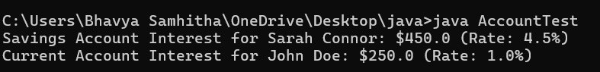

9. Constructor Execution in Multilevel Inheritance
Problem Statement:
Write a Java program to demonstrate the order of constructor execution in multilevel inheritance using the classes Person, Student, and GraduateStudent. Use constructors in all three classes and display messages to show the order in which the constructors are executed.
class Person {
Person() {
System.out.println("1. Person constructor executed (Superclass)");
}
}

class Student extends Person {
Student() {
// Implicit call to super() happens here
System.out.println("2. Student constructor executed (Subclass)");
}
}

class GraduateStudent extends Student {
GraduateStudent() {
// Implicit call to super() happens here
System.out.println("3. GraduateStudent constructor executed (Derived Subclass)");
}
}

public class InheritanceConstructorDemo {
public static void main(String[] args) {
System.out.println("Creating a GraduateStudent object...");

// Instantiating the bottom-most class triggers constructor chaining
GraduateStudent gradStudent = new GraduateStudent();
}
}
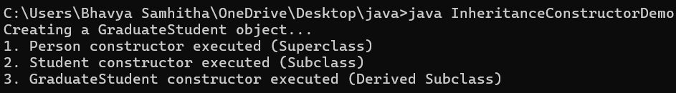

10. Banking Application Using Inheritance
Problem Statement:
Write a Java program to develop a simple banking application using inheritance. Create a BankAccount superclass with account number and balance. Derive SavingsAccount and CurrentAccount classes and provide suitable methods for deposit, withdrawal, and interest calculation. Demonstrate inheritance and method overriding.
class BankAccount {
double balance = 1000;

void withdraw(double amount) {
balance -= amount;
System.out.println("Withdrew: $" + amount + " | Remaining: $" + balance);
}
}

class CurrentAccount extends BankAccount {
@Override
void withdraw(double amount) {
System.out.println("Using overdraft facility...");
super.withdraw(amount);
}
}

public class BankDemo {
public static void main(String[] args) {
CurrentAccount acc = new CurrentAccount();
acc.withdraw(1200);
}
}


